Project 2:- Music Application (Mobile App UI)

Index

* 1. Opening Design…………………………………………………………………………………….. 2
  2. Login…………………………………………………………………………………………………….6
  3. Sign in…….…………………………………………………………………………………………... 10
  4. Playlist…………..…….……………………………………………………………………………… 14
  5. Song Pause…..……………………………………………………………………………………… 18
  6. Song Play……………………………………………………………………………………………… 22
  7. Volume Mute..………………………………………………………………………………………..23
  8. Volume Low……….…………………………………………………………………………………. 26
  9. Volume Medium….………………………………………………………………………………….29
  10. Volume High………..……………………………………………………………………………….. 32
  11. Favourite List………………………………………………………………………………………… 35
  12. Lyrics…………………………………………………………………………………………………… 38
  13. Downloads…………………………………………………………………………………………… 39
  14. Profile …….…………………………………………………………………………………………….42
  15. Overview of project 2 prototype…………………………………………………………………46
  16. Opening Design

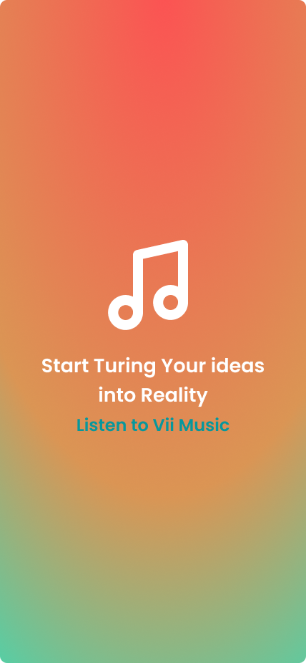

Design Elements:

Color Choices:

* Background Gradient: A smooth gradient transitioning from red (#FC5353) at the top to orange (#DA9554) in the middle, and finally to green (#3ADAB6) at the bottom.
* Icon and Text Color: White (#FFFFFF) for the main text and icon to ensure high contrast against the gradient background.
* CTA Text Color: Dark Teal (#08979C) for "Listen to Vii Music" to distinguish it from the rest of the text and draw attention.

Typography:

* Primary Text: Bold, Poppins font for "Start Tuning Your Ideas into Reality" to ensure readability and emphasis.
* CTA Text: Regular, Poppins font for "Listen to Vii Music" with an underline effect, commonly indicating a clickable link or button.

Iconography:

* A simple, white musical note icon that visually reinforces the context of the message related to music.

Layout:

* Centered Alignment: Both the icon and text are centrally aligned for balanced visual weight and focus.
* Spacing: Adequate spacing between the icon, primary message, and CTA to ensure clarity and readability.

Reasoning:

Color Gradient Background:

* The gradient background is visually appealing and engaging, creating a dynamic and modern look that can capture the user's attention. The transition from warm to cool colors can evoke a sense of creativity and energy, aligning with the message of turning ideas into reality.

High Contrast Text and Icon:

* Using white for the main text and icon ensures high contrast against the gradient background, improving readability and accessibility for users with visual impairments.

Distinctive CTA Color:

* The dark teal color for the CTA text sets it apart from the rest of the content, making it easy to identify the next action the user should take. This color choice is visually harmonious with the background while still standing out.

Icon Usage:

* The musical note icon quickly conveys the theme of the app or service (music-related) without needing extensive explanation. It is a universally recognized symbol, making it user-friendly.

Centered Layout:

* A centered layout creates a balanced and aesthetically pleasing design, ensuring that the user's focus is immediately drawn to the main message and the CTA.

Enhancing User Experience:

Visual Appeal:

* The gradient background and clean design are visually stimulating, creating a pleasant first impression that can enhance user engagement.

Readability and Accessibility:

* High contrast between text/icon and background ensures readability for all users, including those with visual impairments, thus improving the overall accessibility of the design.

Clear Call to Action:

* The distinct CTA guides users on what to do next, reducing confusion and making the navigation process straightforward. This can lead to higher interaction rates and user satisfaction.

Emphasis on Message:

* The bold typography for the main message emphasizes the importance of the text, ensuring that users understand the value proposition quickly.

User Engagement:

* The engaging design elements, combined with a clear and compelling message, are likely to increase user interest and prompt them to take action, thereby improving user retention and satisfaction.
* Overall, the design choices in this image are carefully made to create an engaging, accessible, and user-friendly experience, encouraging users to interact with "Vii Music" effectively.
  1. Login

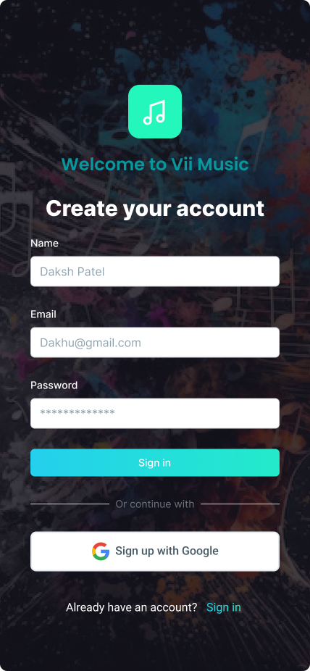

Design Elements:

Color Choices:

* Background: Dark, with a colorful, abstract musical theme. This sets a vibrant, engaging tone while maintaining readability.
* Primary Text Color: White (#FFFFFF) to ensure high contrast and readability against the dark background.
* Highlight Color: Teal (#08979C) for important elements like the logo, main welcome text, and primary button to draw attention.
* Secondary Button Color: Light grey background (#24CEF0) for the Google sign-up button, with dark text for clear differentiation.

Typography:

* Main Heading ("Create your account"): Bold, Poppins font to grab attention and clearly indicate the primary action.
* Subheading ("Welcome to Vii Music"): Medium-sized, Poppins font for a friendly welcome.
* Field Labels and Text: Poppins font for clarity and readability.

Form Elements:

* Input Fields: Rounded corners, white background, grey placeholder text for a clean and modern look.
* Primary Button ("Sign in"): Teal background with white text, rounded corners for a modern aesthetic.
* Secondary Button ("Sign up with Google"): White background, Google logo, and black text to signify an alternative sign-up method.

Layout:

* Centered Alignment: All elements are centrally aligned to create a balanced and cohesive look.
* Spacing: Adequate spacing between the welcome message, form fields, buttons, and the alternative sign-in option to ensure a clear and user-friendly interface.

Reasoning:

Dark Background with Vibrant Colors:

* The dark background with abstract musical graphics creates an engaging and immersive experience, reflecting the creative nature of the app. The vibrant colors ensure the interface feels lively and inviting.

High Contrast Text:

* White text on a dark background ensures readability and accessibility, which is crucial for user experience.

Primary and Secondary Buttons:

* Using teal for the primary action button makes it stand out, guiding users toward the intended action. The secondary Google sign-up button uses lighter colors to indicate an alternative but less emphasized option.

Clear Input Fields:

* The input fields are designed with rounded corners and a clean white background to enhance focus and usability. The placeholder text provides clear guidance on what information to enter.

Visual Hierarchy:

* The use of different font weights and sizes establishes a clear visual hierarchy, making it easy for users to scan and understand the content quickly.

Enhancing User Experience:

Engagement and Aesthetics:

* The visually appealing background with musical elements immediately sets the context and enhances user engagement. It aligns with the brand identity and makes the sign-up process enjoyable.

Readability and Accessibility:

* High contrast between text and background ensures that the content is readable for all users, including those with visual impairments. This is crucial for creating an inclusive user experience.

User Guidance and Clarity:

* Clear headings and labels guide users through the sign-up process effortlessly. The distinct primary button and alternative sign-up option provide clear pathways for different user preferences.

Modern and Clean Design:

* The modern design elements, such as rounded corners and clean input fields, contribute to a polished and professional look. This helps in building trust and credibility with users.

Simplified User Interaction:

* Central alignment and adequate spacing make the interface intuitive and easy to navigate. Users can quickly understand where to input their information and how to proceed with the sign-up process.
* Overall, the design choices in this image are focused on creating an engaging, accessible, and user-friendly experience. The combination of visual appeal, clarity, and intuitive interactions ensures that users can easily create an account and start using "Vii Music" without any friction.
  1. Sign in

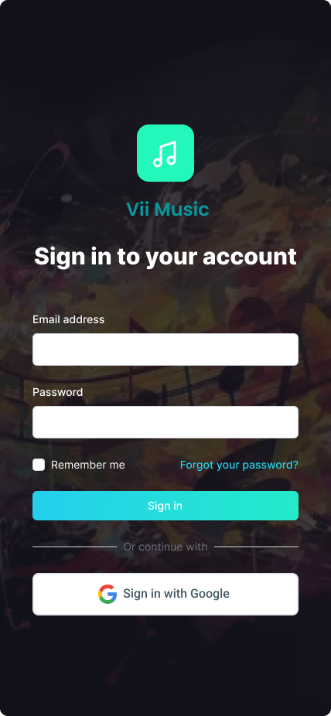

Reasoning:

Layout and Structure:

* Centered Alignment: The form is centered both horizontally and vertically on the page, which creates a balanced and focused user experience.
* Simple and Clean Design: The layout is straightforward with minimal elements, making it easy for users to understand and navigate.

Form Fields:

* Email and Password Fields: These are the essential fields for signing in, placed prominently at the top for easy access.
* 'Remember me' Checkbox: Provides a convenience option for users who prefer not to enter their credentials each time.

Buttons and Links:

* Primary Sign-In Button: Positioned directly below the form fields for a logical flow.
* Forgot Password Link: Positioned to the right of the password field for users who may need it, easily noticeable but not intrusive.
* Alternative Sign-In Option: The 'Sign in with Google' button offers an alternative, quick sign-in method using an existing Google account.

Color Choices:

Background and Theme:

* Dark Background with Abstract Design: The dark background with colorful, abstract musical elements reinforces the theme of the app (music) and provides a visually engaging backdrop without overwhelming the content.
* Background Color: # 151521 (Dark gray/black)
* Abstract Elements: Various vibrant colors (e.g., reds, yellows, blues) to create a musical and dynamic atmosphere.

Form and Buttons:

* Email and Password Fields: White background with dark text ensures readability and a clean look.
* Primary Button: The sign-in button uses a gradient of turquoise to blue, which stands out against the dark background and indicates the primary action.
* Field Background: #FFFFFF (White)
* Field Text: #000000 (Black)

Accent Colors:

* Forgot Password Link: Light blue color, making it noticeable against the dark background but distinct from the primary action button #24D2EA (Light blue)
* Google Sign-In Button: Uses Google's standard branding with the multicolored Google logo, making it instantly recognizable.

Interactions:

* Form Field Focus: When users click on an input field, it likely has an interaction effect (such as a border color change) to indicate that the field is active, enhancing usability.
* Button Hover Effects: Hovering over the 'Sign in' button might change its shade slightly or provide a subtle animation, giving feedback that the button is interactive.
* Checkbox Interaction: Clicking the 'Remember me' checkbox would show a checkmark, confirming the user's action.

Enhancing the Overall User Experience:

Clarity and Simplicity:

* The design is straightforward with a clear visual hierarchy, making it easy for users to understand what actions they need to take without any confusion.

Visual Appeal:

* The dark, abstract musical background adds a thematic touch that is aesthetically pleasing, while the contrast between the form elements and the background ensures readability and focus.

Accessibility:

* High contrast between text and background, as well as clear indicators for form fields and buttons, enhance accessibility for users with visual impairments.

Convenience:

* The 'Remember me' option and the 'Forgot your password?' link provide added convenience, reducing potential friction points in the sign-in process.

Alternative Sign-In Method:

* Including the Google sign-in option caters to users who prefer or find it easier to use existing credentials, streamlining the login process.
* Overall, this design is user-centric, prioritizing ease of use, clarity, and a visually engaging experience that aligns with the app's purpose.
  1. Playlist

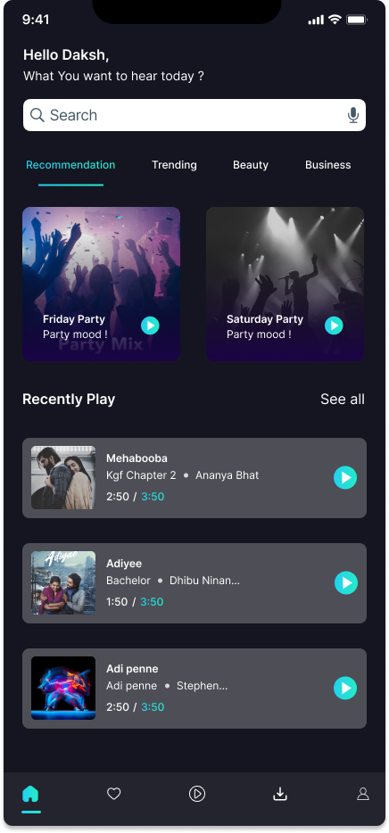

Reasoning:

Layout and Structure:

* Header Section: Greeting the user by name and asking what they want to hear today creates a personalized experience.
* Search Bar: Placed prominently at the top for easy access to search functionality.
* Navigation Tabs: Clear categorization of content (Recommendation, Trending, Beauty, Business) for easy exploration.
* Recently Played Section: Provides quick access to recently played tracks, enhancing convenience for the user.
* Navigation Bar: Persistent bottom navigation bar for easy access to main sections of the app.

Content Cards:

* Recommendation Cards: Visual cards with album artwork and play button for quick interaction.
* Recently Played Tracks: Listed with thumbnail, title, artist, and play duration, making it easy to find previously played content.

Typography:

* Font Choices: Clear and readable fonts for all text elements, ensuring good readability.

Color Choices:

Background and Theme:

Dark Background:

* Background Color: # 151521 (Very dark gray/black), creating a modern and sleek look.

Header and Text:

Header Text:

* Greeting and Questions: #FFFFFF (White), ensuring high contrast and readability.

Tab Text:

* Active Tab: # D9D9D9 (Turquoise) to indicate the selected tab.
* Inactive Tabs: #FFFFFF (White) with lower opacity to show they are not selected.

Search Bar:

* Search Bar Background: #FFFFFF (White) for clear visibility.
* Search Text and Icon: # 151521 (Very dark gray/black) for contrast against the white background.

Navigation Bar:

* Background: #121212 (Very dark gray/black), consistent with the overall app theme.

Icons:

* Active Icon: #00C6FF (Turquoise).
* Inactive Icons: #FFFFFF (White) with lower opacity.

Interactions:

Tab Interaction:

* Active Tab Indicator: Underline or highlight in #00C6FF (Turquoise) to show the selected tab.
* Tab Change Animation: Smooth transition animation to enhance user experience.

Search Bar Interaction:

* Focus State: Slight border glow or change in shadow to indicate active state.

Card Interaction:

* Hover/Active State on Play Button: Slight enlargement or color change of the play button to indicate interactivity.

Navigation Bar:

* Active Icon Highlight: Slightly larger size or color change to #00C6FF (Turquoise) to show active state.
* Smooth Transition: When switching between sections, ensure a smooth animation for a seamless user experience.

Enhancing the Overall User Experience:

* Personalization: Greeting the user by name and providing personalized recommendations make the user feel valued.
* Easy Navigation: Clear categorization and a persistent bottom navigation bar enhance ease of navigation.
* Visual Hierarchy: The use of different font sizes, weights, and colors helps in creating a clear visual hierarchy, making the app easy to scan.
* Consistent Theme: A dark theme with consistent use of color accents ensures a modern look while reducing eye strain.
* Interactive Feedback: Providing visual feedback for interactive elements (like buttons and tabs) enhances the overall user experience by making the interface feel more responsive and engaging.
  1. Song Pause

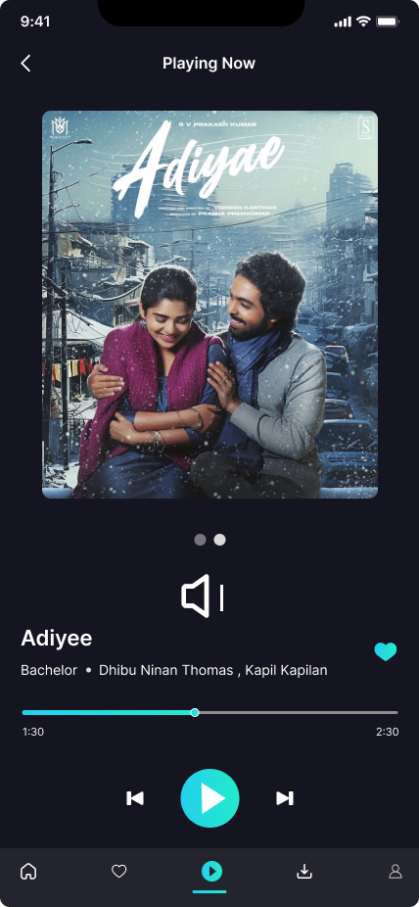

Reasoning:

Layout and Structure:

* Header Section: Simple "Playing Now" text at the top to indicate the current state.
* Album Art: Large, centered album art to visually anchor the page and provide a clear focus on the current track.
* Track Information: Positioned below the album art, including the track title, artists, and album information for easy readability.
* Playback Controls: Centralized at the bottom for easy access and intuitive use.

Controls and Icons:

* Volume Control: Simple, clear icon for adjusting volume.
* Playback Controls: Play/Pause, Previous, and Next buttons are large and easily distinguishable.
* Like Button: Heart icon for quickly adding the track to favorites.

Progress Bar:

* Track Progress: Clear, easily visible progress bar with time markers to indicate track duration and current playback position.

Color Choices:

Background and Theme:

Dark Background:

* Background Color: # 24242E (Very dark gray/black), creating a sleek, modern look that enhances focus on the content and reduces eye strain.

Header and Text:

Header Text:

* Color: #FFFFFF (White), ensuring high contrast and readability against the dark background.

Track Information Text:

* Title: #FFFFFF (White) for high visibility.
* Artists and Album: # 8E8E8E (Light gray) to differentiate secondary information.

Controls and Icons:

Volume Icon:

* Color: #FFFFFF (White) for visibility against the dark background.

Play/Pause Button:

* Color: #00C6FF (Turquoise) to draw attention and indicate the primary action.

Previous and Next Buttons:

* Color: #FFFFFF (White) for consistency with other control icons.

Like Button:

* Default State: #B0B0B0 (Light gray) for a subtle presence.
* Active State: #00C6FF (Turquoise) to indicate the track is a favorite.

Progress Bar:

Progress Line:

* Completed Portion: #00C6FF (Turquoise) for clear visibility.
* Remaining Portion: #B0B0B0 (Light gray) for differentiation.
* Time Markers: #FFFFFF (White) for easy readability.

Interactions:

Volume Control Interaction:

* Active State: Icon changes color or animates slightly to indicate it is being adjusted.

Playback Controls Interaction:

* Play/Pause Button: Changes to a pause icon when playing and back to a play icon when paused. The button slightly enlarges or changes shade on press to provide feedback.
* Previous and Next Buttons: Slight animation or color change on press to indicate interaction.

Like Button Interaction:

* Toggle State: When tapped, the heart icon fills with the turquoise color (#00C6FF) to show the track is liked, providing immediate feedback to the user.

Enhancing the Overall User Experience:

* Focus on Content: The large album art and clear track information ensure users can quickly identify the current playing track.
* Easy Control Access: Playback and volume controls are large and centrally located for intuitive access.
* Visual Feedback: Interactive elements provide immediate visual feedback to enhance user confidence in their actions.
* Consistent Theme: The dark theme with accent colors provides a visually appealing and modern look while maintaining readability and reducing eye strain.
* User Engagement: Features like the like button encourage user interaction and personalization of their listening experience.
  1. Song Play

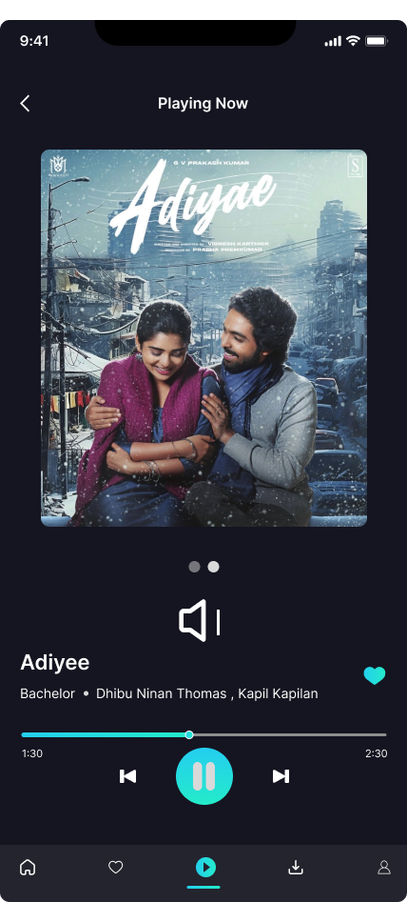

All Reasoning , Color Choices, and Interactions with Color Codes are Same to 1.5 only Pause Button Add.

* 1. **Volume Mute**

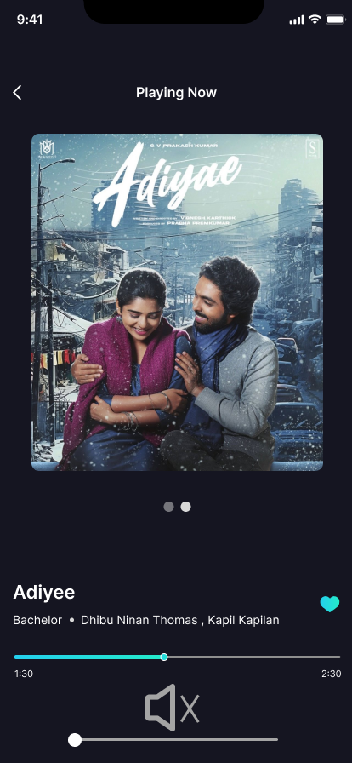

**Current status (Muted in this case**)

**Reasoning:**

**Minimalist Layout:**

* The interface is clean with minimal clutter, focusing on the essential elements like the album cover, song title, and controls.

**Prominent Album Art:**

* The album art is prominently displayed, making it visually appealing and providing context about the song.

**Intuitive Controls:**

* The playback controls (play/pause, volume) are straightforward and easy to understand, enhancing user experience.

**Clear Information Display:**

* Song title, artist name, and duration are clearly displayed, providing necessary information at a glance.

**Color Choices:**

**Dark Theme:**

* The overall dark theme (dark navy blue or black background) helps in reducing eye strain, especially in low-light conditions, and makes the colorful album art pop.

**Accent Colors:**

* Light blue is used as an accent color for the progress bar and heart icon, drawing attention to interactive elements and indicating current status (e.g., song progress).

**Text Color:**

* White text is used for high contrast against the dark background, ensuring readability.

**Interactions:**

**Progress Bar:**

* The progress bar is intuitive, showing the elapsed time and allowing users to seek through the song easily. The light blue color differentiates it from the background.

**Volume Control:**

* The volume icon indicates the **current status (muted in this case**), and the slider allows for quick adjustments. The choice of a simple white icon ensures clarity.

**Heart Icon:**

* The heart icon is used for favoriting the song. Its blue color when active indicates that the song has been liked, providing visual feedback to the user.

**Color Codes**:

* Background: # 24242E (Dark Gray/Black)
* Text: #FFFFFF (White)
* Accent Color (Progress Bar & Heart Icon): # 151521 (Dodger Blue)
* Volume Icon and Slider: #FFFFFF (White)
  1. **Volume Low**

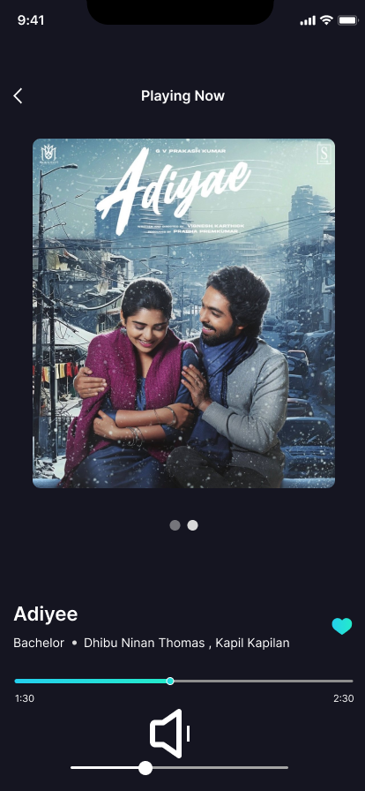

**Current status (Volume Is low in this case**)

**Reasoning:**

**Minimalist Layout:**

* The interface is clean with minimal clutter, focusing on the essential elements like the album cover, song title, and controls.

**Prominent Album Art:**

* The album art is prominently displayed, making it visually appealing and providing context about the song.

**Intuitive Controls:**

* The playback controls (play/pause, volume) are straightforward and easy to understand, enhancing user experience.

**Clear Information Display:**

* Song title, artist name, and duration are clearly displayed, providing necessary information at a glance.

**Color Choices:**

**Dark Theme:**

* The overall dark theme (dark navy blue or black background) helps in reducing eye strain, especially in low-light conditions, and makes the colorful album art pop.

**Accent Colors:**

* Light blue is used as an accent color for the progress bar and heart icon, drawing attention to interactive elements and indicating current status (e.g., song progress).

**Text Color:**

* White text is used for high contrast against the dark background, ensuring readability.

**Interactions:**

**Progress Bar:**

* The progress bar is intuitive, showing the elapsed time and allowing users to seek through the song easily. The light blue color differentiates it from the background.

**Volume Control:**

* The volume icon indicates the **current status (Volume Is low in this case**), and the slider allows for quick adjustments. The choice of a simple white icon ensures clarity.

**Heart Icon:**

* The heart icon is used for favoriting the song. Its blue color when active indicates that the song has been liked, providing visual feedback to the user.

**Color Codes**:

* Background: # 24242E (Dark Gray/Black)
* Text: #FFFFFF (White)
* Accent Color (Progress Bar & Heart Icon): # 151521 (Dodger Blue)
* Volume Icon and Slider: #FFFFFF (White)
  1. **Volume Medium**

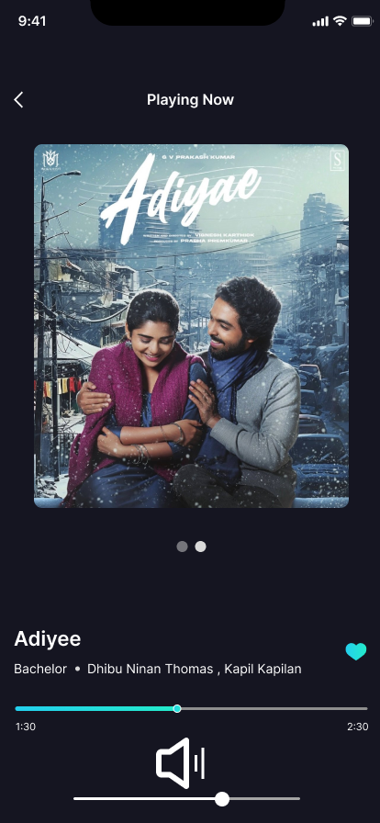

**Current status (Volume is medium in this case**)

**Reasoning:**

**Minimalist Layout:**

* The interface is clean with minimal clutter, focusing on the essential elements like the album cover, song title, and controls.

**Prominent Album Art:**

* The album art is prominently displayed, making it visually appealing and providing context about the song.

**Intuitive Controls:**

* The playback controls (play/pause, volume) are straightforward and easy to understand, enhancing user experience.

**Clear Information Display:**

* Song title, artist name, and duration are clearly displayed, providing necessary information at a glance.

**Color Choices:**

**Dark Theme:**

* The overall dark theme (dark navy blue or black background) helps in reducing eye strain, especially in low-light conditions, and makes the colorful album art pop.

**Accent Colors:**

* Light blue is used as an accent color for the progress bar and heart icon, drawing attention to interactive elements and indicating current status (e.g., song progress).

**Text Color:**

* White text is used for high contrast against the dark background, ensuring readability.

**Interactions:**

**Progress Bar:**

* The progress bar is intuitive, showing the elapsed time and allowing users to seek through the song easily. The light blue color differentiates it from the background.

**Volume Control:**

* The volume icon indicates the **current status (Volume Is Medium in this case**), and the slider allows for quick adjustments. The choice of a simple white icon ensures clarity.

**Heart Icon:**

* The heart icon is used for favoriting the song. Its blue color when active indicates that the song has been liked, providing visual feedback to the user.

**Color Codes**:

* Background: # 24242E (Dark Gray/Black)
* Text: #FFFFFF (White)
* Accent Color (Progress Bar & Heart Icon): # 151521 (Dodger Blue)
* Volume Icon and Slider: #FFFFFF (White)
  1. **Volume High**

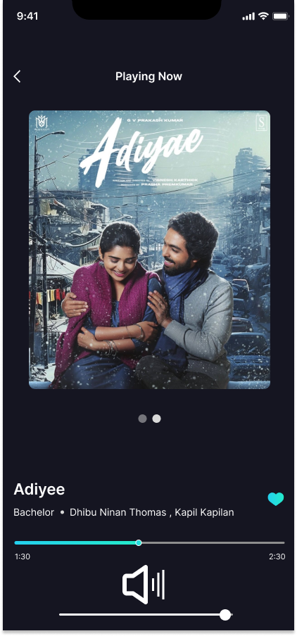

**Current status (Volume Is High in this case**)

**Reasoning:**

**Minimalist Layout:**

* The interface is clean with minimal clutter, focusing on the essential elements like the album cover, song title, and controls.

**Prominent Album Art:**

* The album art is prominently displayed, making it visually appealing and providing context about the song.

**Intuitive Controls:**

* The playback controls (play/pause, volume) are straightforward and easy to understand, enhancing user experience.

**Clear Information Display:**

* Song title, artist name, and duration are clearly displayed, providing necessary information at a glance.

**Color Choices:**

**Dark Theme:**

* The overall dark theme (dark navy blue or black background) helps in reducing eye strain, especially in low-light conditions, and makes the colorful album art pop.

**Accent Colors:**

* Light blue is used as an accent color for the progress bar and heart icon, drawing attention to interactive elements and indicating current status (e.g., song progress).

**Text Color:**

* White text is used for high contrast against the dark background, ensuring readability.

**Interactions:**

**Progress Bar:**

* The progress bar is intuitive, showing the elapsed time and allowing users to seek through the song easily. The light blue color differentiates it from the background.

**Volume Control:**

* The volume icon indicates the **current status (Volume Is High in this case**), and the slider allows for quick adjustments. The choice of a simple white icon ensures clarity.

**Heart Icon:**

* The heart icon is used for favoriting the song. Its blue color when active indicates that the song has been liked, providing visual feedback to the user.

**Color Codes**:

* Background: # 24242E (Dark Gray/Black)
* Text: #FFFFFF (White)
* Accent Color (Progress Bar & Heart Icon): # 151521 (Dodger Blue)
* Volume Icon and Slider: #FFFFFF (White)
  1. **Favourite List**

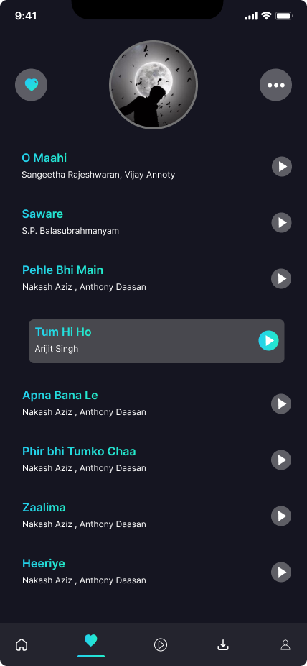

**Reasoning:**

**Minimalist Layout:**

* The interface uses a minimalist design, which reduces clutter and makes it easier for users to focus on the core functionality—playing and managing music.

**Consistent Iconography:**

* Icons for playing music, favoriting, and accessing more options are simple and consistent, enhancing usability.

**Clear Text Hierarchy:**

* The text hierarchy is well-defined, with song titles and artist names clearly distinguished through font size and color.

**Color Choices:**

**Dark Background:**

* The dark background (#181829) helps create a visually appealing contrast with the text and icons, making them stand out. It also aligns with common designs in media apps that aim to minimize eye strain, especially in low-light conditions.

**Accent Colors:**

* Primary Accent Color: The turquoise (approximately #00FFFF) is used for active elements, such as song titles and icons, indicating interactive components. This color choice ensures that the interactive elements stand out against the dark background.
* Secondary Accent Color: The play icon and favorite icon have a slightly lighter shade of turquoise, which maintains visual consistency and indicates action points.
* Selected Item Highlight: The current playing song, "Tum Hi Ho," is highlighted with a slightly brighter and more prominent shade of turquoise, making it easy for users to identify the currently playing track.

**Interactions**

**Play Button:**

* Each song has a play button on the right, using the turquoise color to indicate that it is interactive and ready for action. When a song is playing, the play button changes to a pause icon, providing immediate visual feedback.

**Favorite Button:**

* The heart icon at the top left is filled with turquoise, indicating that the user has favorited this song or playlist. This provides a quick visual indicator of favorite status.

**Selection Feedback:**

* When a song is selected, the entire row is highlighted with a turquoise background, providing clear feedback about the current selection.

**Color Codes:**

* Dark Background: #5E5E65 (Approximate)
* Primary Accent Color (Turquoise): #00FFFF
* Secondary Accent Color (Lighter Turquoise): Slightly lighter shade of #00FFFF
* Text Color: White (#FFFFFF), providing high contrast against the dark background.
* Highlight Color for Selected Item: Brighter shade of turquoise, ensuring it stands out.
* These design choices and color interactions work together to create an intuitive, visually appealing, and easy-to-navigate interface. The use of a dark background with bright accent colors ensures that important elements are easily noticeable, enhancing the overall user experience.
  1. **Lyrics**

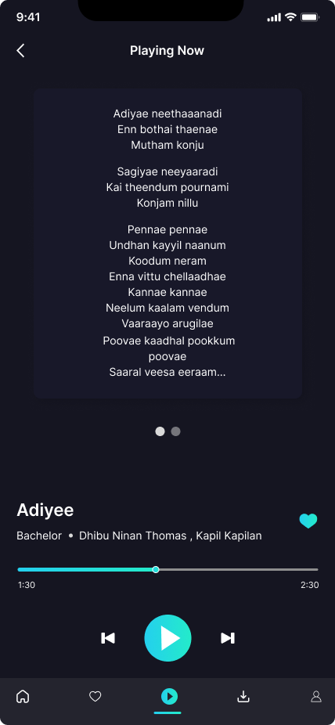

**Lyrics Display:**

* The lyrics are prominently displayed in the center of the screen, with a clear, readable font. This feature enhances user engagement by allowing users to sing along with the song.

All Design Decisions, Color Choices, and Interactions with Color Codes are Same as 1.5

* 1. **Downloads**

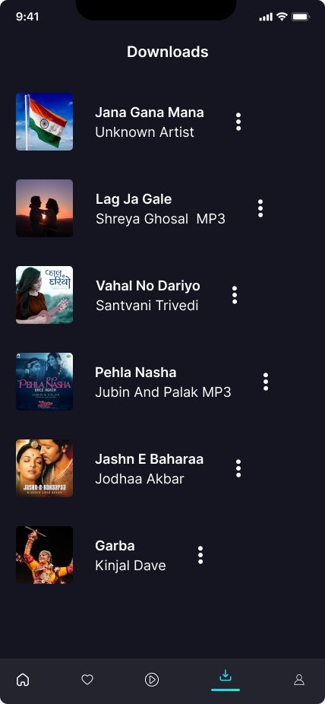

**Reasoning:**

**List View Layout:**

* The screen uses a list view layout, displaying downloaded songs in a vertical list. This format is familiar to users and makes it easy to scroll through and find specific downloads.

**Thumbnail Images:**

* Each song entry includes a thumbnail image, which helps users quickly identify songs visually. The thumbnails add a visual appeal to the list.

**Ellipsis Menu:**

* The three-dot ellipsis menu next to each song entry provides access to additional options (e.g., play, delete, share), keeping the main interface clean and uncluttered.

**Text Hierarchy:**

* Song titles are displayed in a larger, bold font, while artist names are shown in a smaller, lighter font. This text hierarchy ensures that the most important information (the song title) stands out.

**Color Choices**

**Dark Background:**

* The dark background (#151521) is consistent with other screens, providing a uniform look and reducing eye strain.

**Accent Colors:**

* Primary Accent Color (Turquoise): The turquoise color (#00FFFF) is used minimally here, primarily for the active download icon at the bottom and potentially for highlighting selected items or actions.
* Text Colors: White (#FFFFFF) is used for song titles and other important information to ensure readability against the dark background.
* Secondary Text Color: A lighter gray (#151521) is used for artist names and additional song information, creating a clear distinction from the song titles.

**Interactions**

**Ellipsis Menu:**

* Tapping the three-dot ellipsis menu opens additional options for each song. This interaction is indicated by the presence of the three dots, a common UI pattern for accessing more options.

**Navigation Bar:**

* The navigation bar at the bottom includes icons for different sections of the app. The current section (Downloads) is highlighted with the turquoise accent color, indicating the active state.
* The icons provide quick access to other sections, improving overall navigation within the app.

**Thumbnail Interaction:**

* Tapping on a song entry (including the thumbnail) would likely initiate playback or open a detailed view of the song. This interaction is intuitive, as users expect to access content by tapping on it.

**Color Codes:**

* Dark Background: # 151521
* Primary Accent Color (Turquoise): #00FFFF
* Text Color (White): #FFFFFF
* Secondary Text Color (Light Gray): # 151521
* Ellipsis Menu Icon: White (#FFFFFF), maintaining visibility against the dark background.

**Overview:**

* The "Downloads" screen effectively uses design principles and color choices to create a user-friendly interface. The dark background with white text ensures readability, while the use of turquoise accent color highlights interactive elements. The list view layout with thumbnails makes it easy for users to browse their downloads, and the ellipsis menu keeps the interface clean by providing additional options without cluttering the main screen. The consistent use of colors and design elements across different screens enhances the overall user experience, making the app intuitive and visually appealing.
  1. **Profile**

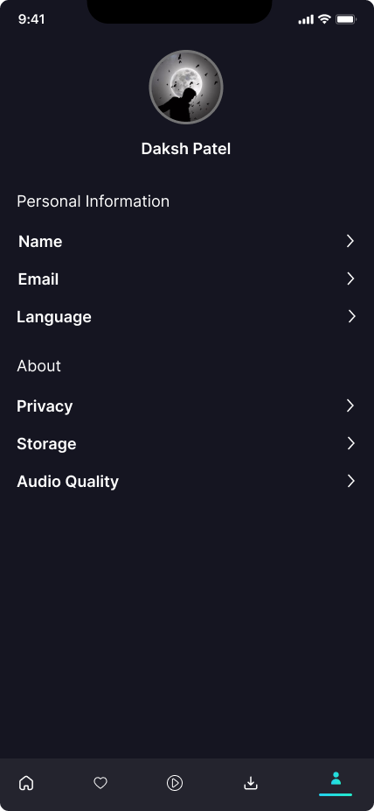

**Reasoning:**

**Minimalist Design:**

* The interface adopts a minimalist design approach, which is evident from the clean and simple layout. This helps in keeping the focus on the essential elements without overwhelming the user.

**Hierarchy and Organization:**

* Sections are clearly divided into "Personal Information" and "About". This logical grouping makes it easier for users to find the information or settings they need.

**Navigation and Accessibility:**

* The use of icons at the bottom for navigation is standard in mobile apps, ensuring users can easily switch between different sections.
* Arrow indicators (chevrons) suggest that each item can be tapped to access further details, providing intuitive interaction cues.

**Color Choices**

**Background and Foreground Contrast:**

* Background: Dark gray
* Hex Code: # 151521
* Text and Icons: White or light gray for high contrast
* Hex Code: #FFFFFF for pure white text

**Accent Colors:**

* Accent Color for Active Tab: A bright cyan/teal color is used to highlight the active tab in the bottom navigation.
* Hex Code: #151521

**Profile Picture Background:**

* The profile picture uses a monochromatic scheme with shades of gray, which fits well with the overall dark theme.

**Interactions:**

**Tappable Items:**

* Each item (Name, Email, Language, Privacy, Storage, Audio Quality) has a chevron indicating that it's tappable. When tapped, these likely lead to another screen or modal where users can view or edit settings.

**Bottom Navigation:**

* The bottom navigation icons suggest different functionalities, with the active icon highlighted in cyan. Other icons are presumably in a default light gray or white color.

**User Profile:**

* The user profile section at the top indicates a personal space where users can see their profile picture and name, possibly leading to profile settings when tapped.
* By maintaining a consistent color scheme and providing clear interactive elements, this design ensures both aesthetic appeal and functional usability.

**Overview of project 2 prototype**

